Air cycle machine individual exercise

Task 1

There are several different ways in which a suitable tree could be built for this system.

One possibility is:

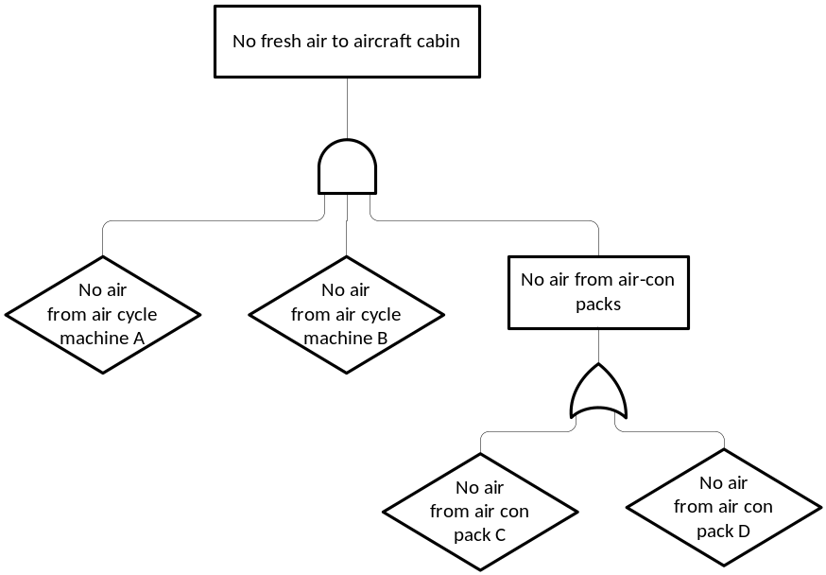

Task 2

Obvious physical common causes from the description include the bleed air system (which is common to the two air cycle machines) and the engines (which power everything) and common controls There is a limit to how much can be done about these, given the obvious constraints of a platform such as an aircraft.

We could also identify human, procedural and quality control aspects such as common manufacturer, common errors in installation, or common errors in maintenance. The effects of this type of commonality can be controlled (at least to some degree) by good process management and operational procedures.

Although it is not required by the question, the figure on the next page shows an extension to the initial fault tree above which shows how the tree could be extended to include some of the physical common causes (bleed air and engines).
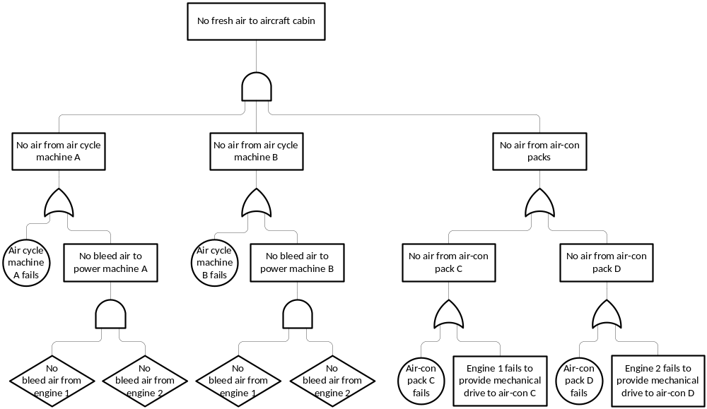

AGV Case Study Group Exercises

Task 1

Taking the case in which the drive motor does not stop, we find that this will occur if:
- power continues to be supplied to the motor (i.e. the power relay is not tripped) and
- the control system does not stop the motors and
- at least one of the brakes is not applied.
Each of these requires further investigation:

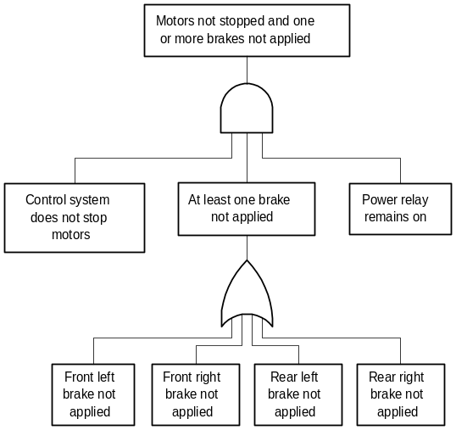

Notice that we are making a simplification here; we are assuming that brakes either work fully, or not at all. Of course, this is not realistic; there are many ways in which a brake system could continue to work, but with reduced effectiveness. This would actually be very hard to model in a fault tree. We could, for example, introduce the event "Overall braking effectiveness less than 75% of normal" – but it would then be extremely hard to determine all the possible sets of failures which could cause this.

For fault tree modelling, it is far easier, and perfectly acceptable, to make a simplification provided we can be certain that it is a pessimistic simplification. In other words, we assume that any failure will have the worst-case outcome – in this case considering all situations in which the effectiveness of the brakes is reduced to be equivalent to "Brake not applied".

The case in which the motor stops, but fewer than two brakes are applied is hard to express in conventional AND-OR fault tree gates. If we call the four wheel brakes Front Left (FL), Front Right (FR), Rear Left (RL) and Rear Right (RR), then vehicle fails to stop if:
- FL, FR and RL fail or
- FL, FR and RR fail or
- FL, RL and RR fail or
- FR, RL and RR fail or
- FL, FR, RL and RR all fail
Clearly, we do not need to include the last of these cases in our tree, since it requires four coincident failures, any three of which are sufficient to prevent the vehicle stopping anyway.

The M of N gate, which produces an output if M of its N inputs (here 3 of 4) occur is ideal to represent this situation:

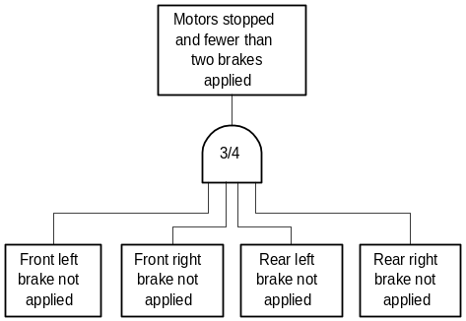

The sub-trees investigating failure causes for each of the four brake failures are repeated between this part of the tree and the OR gate for "At least one brake not applied" on the previous page. It is also clear that they will be identical for all four wheels. We therefore develop a single tree for "Single wheel brake not applied".

Task 2

At this point, another of the fault tree construction guidelines becomes useful - that of distinguishing between primary, secondary and command failures. In this case, we can interpret these as follows:
- Primary failure
The brake mechanism in the wheel itself has failed. This has to be left as an undeveloped event, as the system description does not give any information about the design of the brake mechanism.
- Secondary failure
There is no failure of the brake mechanism itself, but the hydraulic supply which operates the brakes fails. This event requires further investigation.
- Command failure
The control system does not send the signal to apply the brakes. This event also requires further investigation.

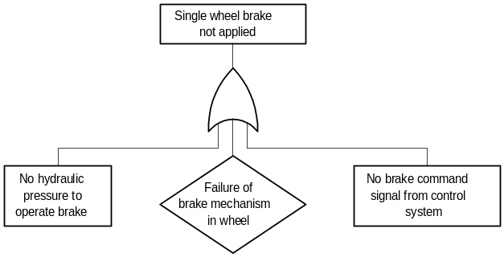

The causes of hydraulic system failure can be developed easily; most of the identified causes are basic events:

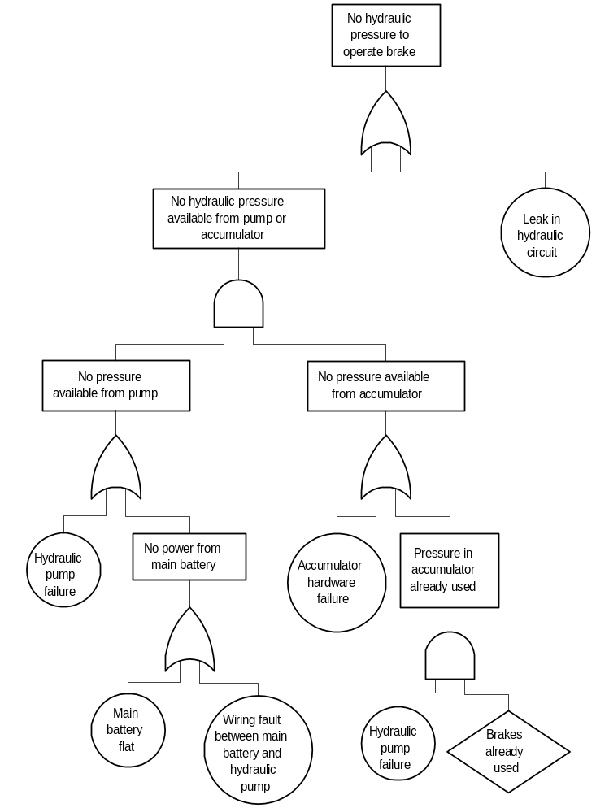

There is one event in this tree that is worth particular comment – the undeveloped event "Brakes already used". We observe that the accumulator only holds sufficient reserve hydraulic pressure for a single application of the brakes; it is intended to provide a means of stopping the vehicle if the hydraulic pump cannot provide the necessary pressure. However, the description of the system makes no mention of any means of detecting that the pump has failed. In case of pump failure, the control system must ensure that the vehicle is stopped and does not move again until pressure from the pump has been restored. Our safety analysis has identified a deficiency in the design as described.

"No brake command signal from control system" can also be developed quite simply:

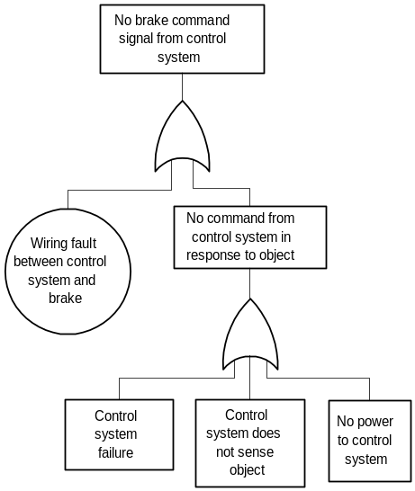

Notice that we have again made an assumption to simplify the analysis. There are many possible ways in which commands from the control system could be incorrect. However, in the same way that we simplified analysis of braking mechanism failure by assuming any reduction in efficiency was equivalent to having no braking at all, here we (pessimistically) assume that any incorrect command will result in complete failure to apply the brakes.

Notice also that we have used the primary / secondary / command distinction again to derive the bottom three events in this fragment of the tree:
- primary is failure of the control system itself,
- secondary is failure of the power supply to the control system, and
- command identifies failure of the input to the control system, causing it to behave incorrectly.
If we had more detail of the control system itself, we could approach this part of the tree in a rather different way, and actually trace the causes of loss of braking commands down through the software and hardware design of the control system in more detail. At this level, however, it is most appropriate simply to note that there are both hardware and software contributions to control system failure, and leave them as undeveloped events:

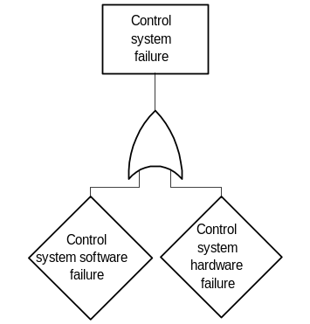

The causes of "No power to control system" are easy to identify, and are all basic events.

There are two systems by which the AGV can sense objects; the proximity sensors, and the bumpers. The proximity sensors provide inputs directly to the control system. However, the bumpers are used to open the power relay, cutting off power to the drive motors, and it is the power cut-off that the control system can sense. Therefore, apart from the possibility of a wiring fault between the power relay and the control system, the development of "No signal from power relay" will be the same as for the event "Power relay remains on" which we encountered earlier, and have not yet investigated:

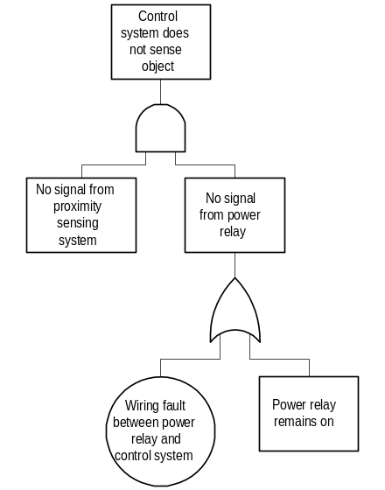

There are two proximity sensors, one each for forward and reverse travel. The sub-trees for each direction of travel will be equivalent:

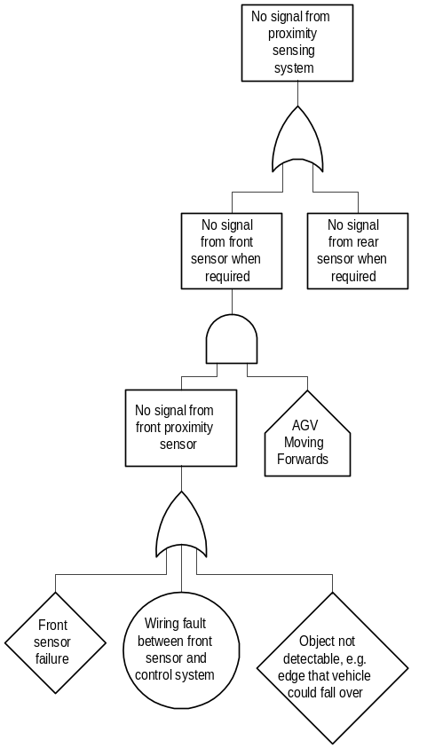

There are two further events left to develop: "Control system does not stop motors" and "Power relay remains on".

"Control system does not stop motors" implies either a wiring fault between the control system and the motors, or a failure of the control system to issue a command to stop the motors. This turns out to be exactly the same as failure of the control system to issue a braking command:

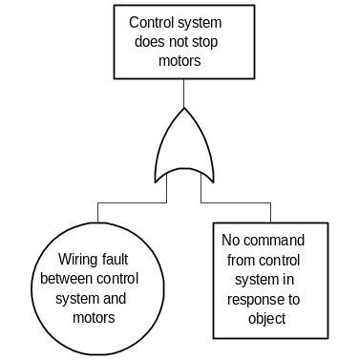

The tree for "Power relay remains on" is similar to that for failure of the proximity sensing system, in that there will be two equivalent sub-trees for the two directions of travel. These sub-trees again end in undeveloped events; mechanical failure of the bumper mechanism itself, for which we do not have a detailed description, and "Object not detectable…". Note that an equivalent event also forms part of the tree for proximity sensing, i.e. there may be objects which cannot be detected by either the proximity sensors or the bumpers. A full safety argument for the AGV system would certainly require detailed investigation to ensure that this does not compromise the overall safety of the system.

Task 3
The idea is to use transfer gates to properly connect the ‘modular’ trees that have been developed so far.

The complete fault tree for AGV collision is presented on pages 10-14.

Task 4 (Optional)
"Obstacle in path of AGV" can be developed into two cases; mobile objects and fixed objects or edges. As several AGVs operate in the same area, and it is not closed to people, we must regard "Mobile object in path of AGV" as a normal event. For a fixed object (or edge) to be in the path of the AGV, however, implies some sort of failure (fixed objects and edges should be in the map file and the AGV should avoid them), so this event needs development:
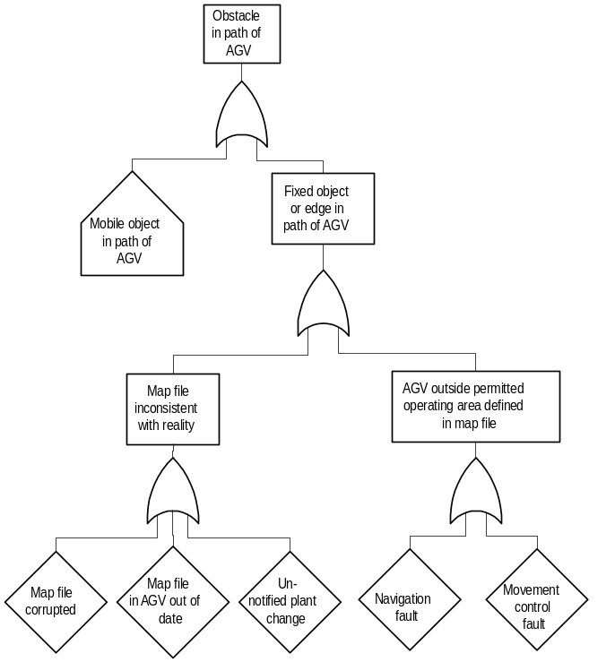

Note that here we are not distinguishing between objects the AGV may hit and edges it may fall over; that distinction will be considered when we investigate detection mechanism failures involved in "AGV fails to stop in time to avoid obstacle".

It is not possible to develop this part of the fault tree any further, as the system description does not give sufficient detail about the central computer that directs the AGVs, the control system in the vehicle itself, or the mechanism used to communicate between the central computer and the vehicles. We therefore leave all the leaf events in this part of the tree as undeveloped events.

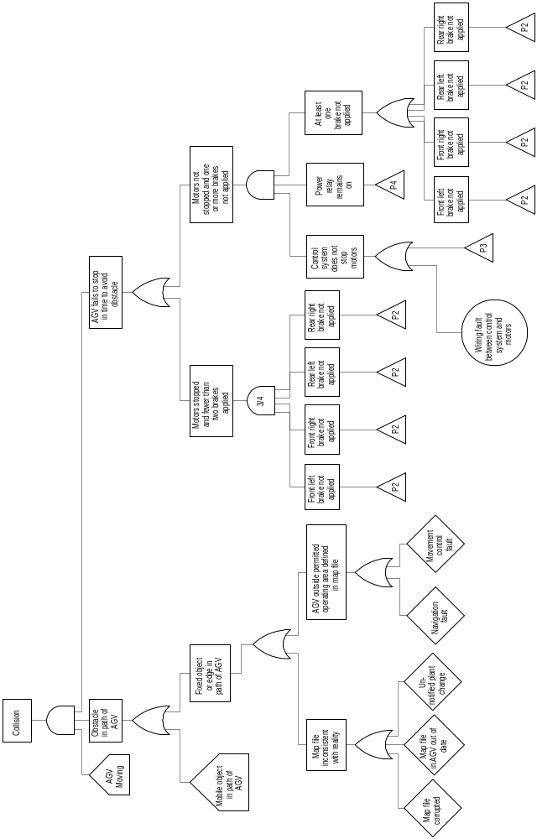
Fault Tree for AGV Collision - Page 1

Fault Tree for AGV Collision - Page 2

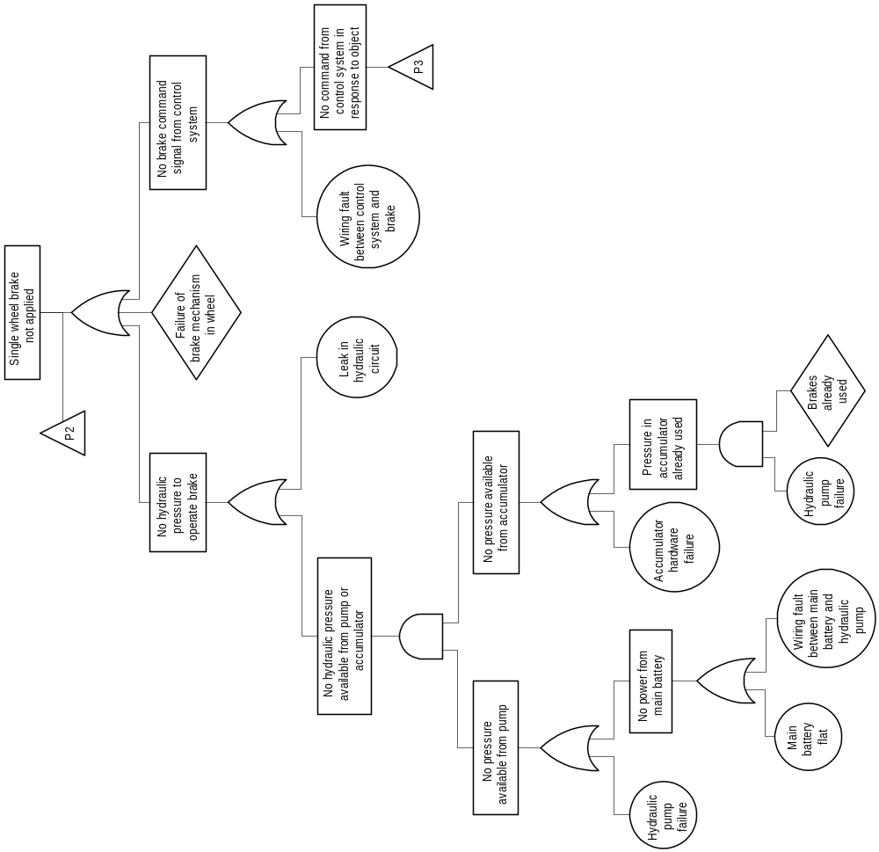

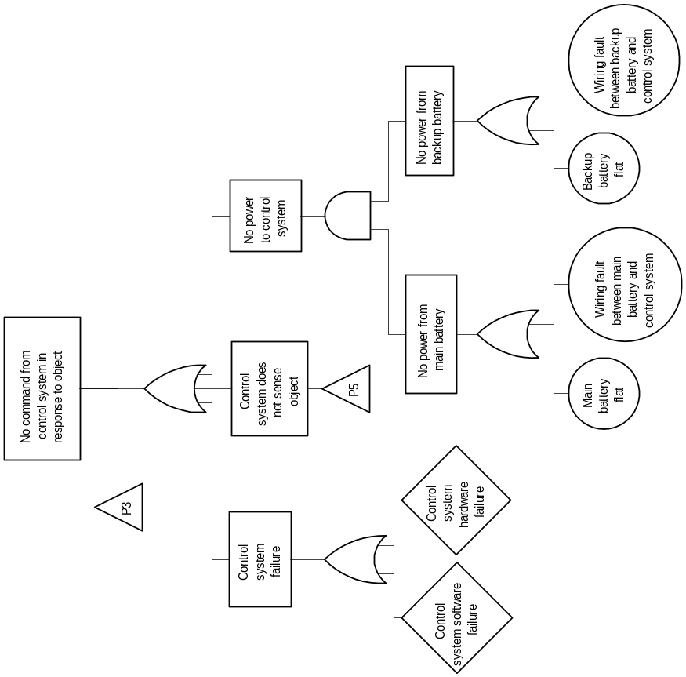
Fault Tree for AGV Collision - Page 3

Fault Tree for AGV Collision - Page 4

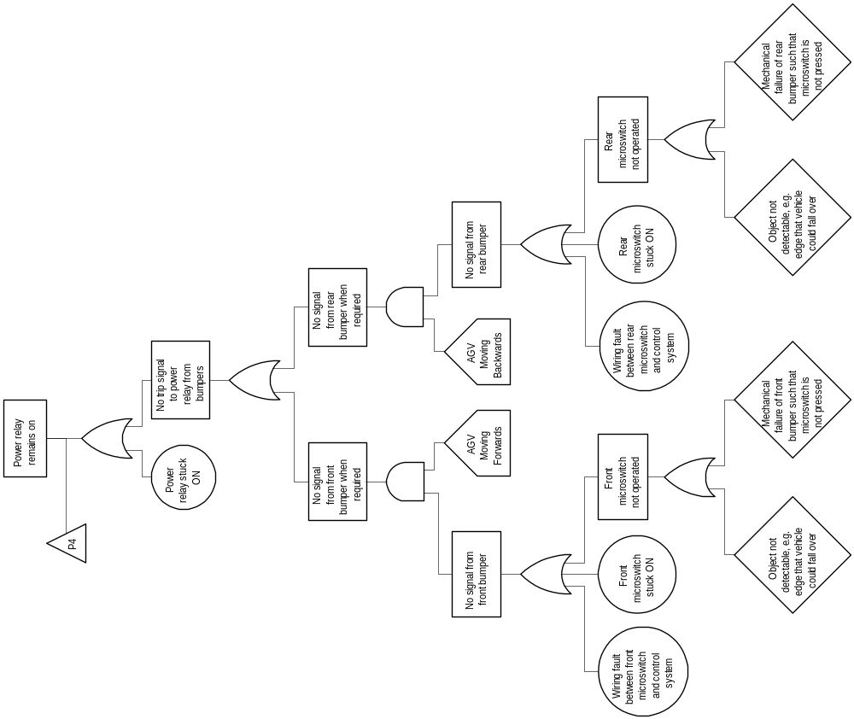

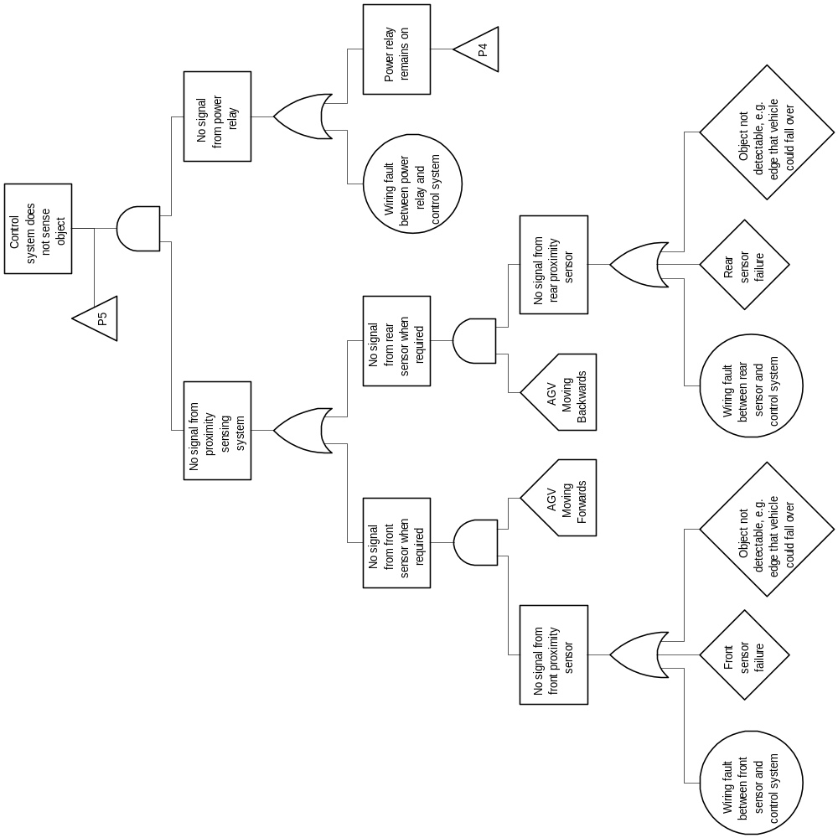
Fault Tree for AGV Collision - Page 5

